**Class Attendance Mobile App**

Use Case Specification

Submitted to:

Asst. Prof. Ma. Rowena C. Solamo

Faculty Member

Department of Computer Science

College of Engineering

University of the Philippines, Diliman

Submitted by:

Atienza,​ ​John​ Oliver

Austria,​ ​Ronnel​​ Roi

Gabriel,​ ​Kristianne​ Arielle

In partial fulfillment of academic requirements

for the course

CS 191 Software Engineering I

of the

1st Semester, AY 2017-2018

***Unique Reference:***

The documents are stored in the GitHub repository:

<https://github.com/rbaustria/ClassAttendanceMobileApp>

***Document Purpose:***

The document provides the Use Case specification of the software, Class Attendance Mobile App.

***Target Audience:***

The target audience of the document are: the developers of the software, future developers who wish to extend it, and the professor.

***Revision Control***

*History Revision:*

|  |  |  |  |
| --- | --- | --- | --- |
| ***Revision Date*** | ***Person Responsible*** | ***Version***  ***Number*** | ***Modification*** |
| 10/09/17 | Arielle Gabriel | 1.0 | Initial Document |

*Use-Case Name*: 2.4 View list of classes

*Description:* This use-case shows the list of previously added classes. If there is no previously added classes, the application will simply show a blank list.

*Preconditions:* None

*Flow of Events:*

|  |  |
| --- | --- |
| ***Scenario Name*** | ***Description*** |
| Scenario 1 (Basic Flow)  Teacher views the list of classes | 1. Teacher clicks the ``view classes’’ button. 2. The application gets the list of classes from the database. 3. Teacher is shown the list of previously created classes. |

*Activity Diagram of the Flow of Events:*

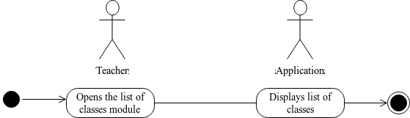

*Postcondition:* NONE

*Relationships:* NONE

*Special Requirements:*

NONE